DAYANANDA SAGAR UNIVERSITY
KUDLU GATE, BENGALURU - 560068



Bachelor of Technology
in
COMPUTER SCIENCE AND ENGINEERING

DATA SCIENCE PROJECT REPORT (20CS3620)

LEGAL CITATION TEXT

By
Vivek Belagali - ENG20CS0414
Under the supervision of
Dr Jayita Saha
Assistant Professor, Department of CSE

DEPARTMENT OF COMPUTER SCIENCE & ENGINEERING
SCHOOL OF ENGINEERING
(2022-2023)
LEGAL CITATION TEXT
Vivek Belagali
Department of computer science and engineering
Dayananda sagar university
Bangalore, Karnataka

Abstract - Legal citation text analysis is a crucial task in the field of law and order. The objective of this project is to develop a machine learning model to classify legal citation text into relevant categories. The dataset used in this project consists of legal citation text extracted from various legal documents. The dataset is pre-processed and converted into numerical vectors using various natural language processing techniques such as tokenization, stemming, and vectorization. The pre-processed dataset is then used to train and test various machine learning models such as Random Forest, Random Forest, Linear Regression SVM.. The performance of each model is evaluated based on accuracy, precision, recall, and F1 score. The developed model can be used to classify legal citation text into relevant categories with high accuracy, which can be useful for legal practitioners and researchers in the field of law and order.

This type of dataset can be used for various tasks related to legal text analysis, such as predicting case outcomes based on the text of the case or identifying patterns and trends in legal cases. To work with this type of dataset, you might use natural language processing techniques to pre-process and analyse the text data, such as tokenization, stop word removal, and stemming. To work with this type of dataset, you might use natural language processing techniques to pre-process and analyse the text data, such as tokenization, stop word removal, and stemming.

Keywords: Supervised techniques, logistic regression, random forest, linear support vector machine.

I. INTRODUCTION
Legal citation text dataset is a collection of text data that consists of various legal documents such as court cases, laws, statutes, and regulations. The dataset includes information about the source and context of the legal text, including the court, jurisdiction, date, and other relevant information required for proper citation.
The dataset is collected from kaggle website and it contains 4 columns and 24985 rows. The dataset includes structured and unstructured data from legal opinions, law reviews, legislative documents, and other legal sources. The structured data includes the name of the case, the court or jurisdiction, the year of the decision, and other relevant information necessary for proper legal citation. The unstructured data includes full-text documents that may require pre-processing and cleaning for use in machine learning applications. Machine learning model that supports this dataset are Logistic Regression, Linear Support Vector Machine, Random Forest.
Given the extensive nature of legal texts, summarizing them into concise and informative summaries can be beneficial for quick information retrieval and decision-making. Machine learning techniques can be employed to generate concise summaries of legal texts, highlighting key points and relevant information.
Legal texts can be classified into different categories based on their subject matter, jurisdiction, or other relevant criteria. Natural language processing techniques can be applied to analyse legal texts and extract relevant information, such as named entities (e.g., names of parties involved), key terms, legal concepts, and relationships between different elements in the text. This analysis can provide valuable insights for legal research, case preparation, and legal strategy development.

ii. LITERATURE SURVEY

The legal citation.csv dataset from Kaggle is a well-known dataset in the legal, NLP, cases. The dataset has been used in several studies to develop predictive models for case outcomes.
1. "Legal Text Mining and Information Retrieval: A Survey" by Richard P. Klump and Gregory J. Arnold (2009) This survey provides an overview of techniques and methodologies used in legal text mining and information retrieval. It covers topics such as legal document representation, text classification, legal information retrieval, and legal question answering. The survey explores various approaches, including rule-based methods, statistical models, and machine learning algorithms, highlighting their applications and challenges in the legal domain.
2."Legal Case Classification Using Machine Learning Techniques" by Chrisopther G. Harris and Sargur N. Srihari (2016) This paper explores the use of machine learning techniques for legal case classification. It investigates the application of different supervised learning algorithms, including support vector machines (SVM), decision trees, and random forests, for categorizing legal cases based on their textual content. The study analyzes the performance of these algorithms on a dataset of U.S. Supreme Court cases and provides comparative results and insights into the effectiveness of different approaches
3. "Automated Legal Citation Extraction and Analysis: A Survey" by Haiguang Li, Brandon Lockhart, and Hsinchun Chen (2020) This survey provides an in-depth exploration of automated legal citation extraction and analysis techniques. It covers various aspects, including citation extraction methods, citation network analysis, citation impact analysis, and the use of citations for legal research and case analysis. The survey discusses challenges, such as citation variation and ambiguity, and presents approaches that leverage machine learning, natural language processing, and network analysis for extracting and analysing legal citations.
4. "Predicting the Outcome of Legal Cases: A Text Classification Approach" by Daniele Bonadiman, Rossana Damiano, and Amelia G. C. Turcatel (2017) This research paper presents a text classification approach for predicting the outcome of legal cases. It explores the application of machine learning algorithms, including support vector machines (SVM) and random forests, for classifying legal cases based on their textual features. The study evaluates the performance of these models using a dataset of Italian administrative court decisions and discusses the potential implications of automated case outcome prediction in the legal domain

III. METHODOLOGY
3.1 Data preprocessing:
Missing data can significantly impact the analysis and modelling process. To handle missing values in the legal citation text.csv dataset, we employ one or more of the following techniques which includes deletion or removal of missing values .It even consists of duplicate value which must be removed to perform further analysis.
Outliers, which are extreme values deviating from the normal distribution, can distort the analysis results. Here we should remove Nan values, null values, remove punctuation in case text column, and making the case consistent as lower.
Data pre-processing is a crucial step in data analysis and machine learning tasks. It involves transforming raw data into a clean, consistent, and suitable format for further analysis and model building. Data pre-processing encompasses various techniques to handle missing values, outliers, feature scaling, categorical data encoding, and more. The goal is to improve the quality and reliability of the data, making it ready for effective analysis and modelling

3.2 Data Visualisation:
Data visualization is the representation of data and information in visual formats, such as charts, graphs, and maps, to facilitate understanding and communication. It is an essential component of data analysis and plays a crucial role in exploring patterns, trends, and relationships within data.
Here we had find the number of case outcomes in the form of pie chart and bar chart.
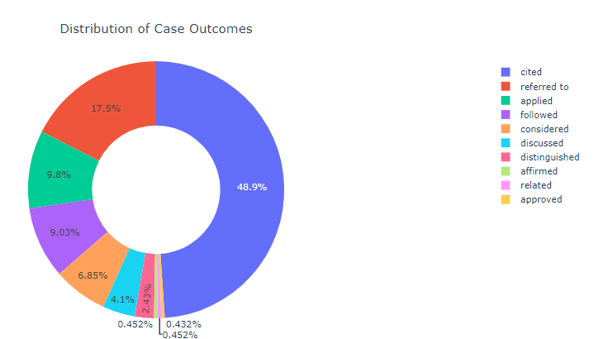

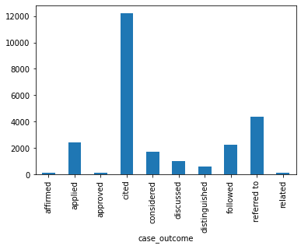
3.3 Algorithms.
We have used supervised learning methodology for the implementation. The algorithms which we have used in the supervised learning are:
Logistic regression: Logistic regression is a machine learning algorithm that is commonly used for binary classification problems. It is a type of regression analysis that predicts the probability of an event occurring based on a set of independent variables. In logistic regression, the dependent variable is binary, meaning it can only take one of two possible values. The independent variables can be continuous, discrete, or categorical. The goal of logistic regression is to find the best set of coefficients for the independent variables that maximizes the likelihood of the observed data. Logistic regression is a relatively simple and interpretable algorithm, making it popular for many applications. It is commonly used in fields such as finance, healthcare, and marketing for predicting customer churn, fraud detection, and legal citation text and disease diagnosis.
One of the advantages of logistic regression is that it can handle both continuous and categorical independent variables, making it a versatile algorithm. It is also less prone to overfitting compared to other machine learning algorithms, such as decision trees or support vector machines. However, logistic regression assumes that the relationship between the independent variables and the dependent variable is linear, which may not always be the case in real-world applications. Additionally, logistic regression is not suitable for problems with multiple dependent variables or non-linear relationships between variables. In summary, logistic regression is a powerful and widely-used machine learning algorithm that is particularly effective for binary classification problems. Its simplicity, interpretability, and versatility make it a popular choice for many applications.
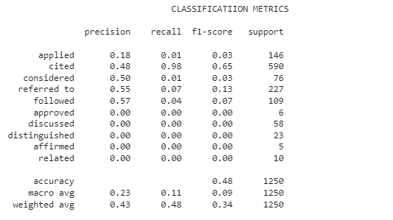
Figure 1 LOGISTIC REGRESSION CLASSIFICATION MEASURES
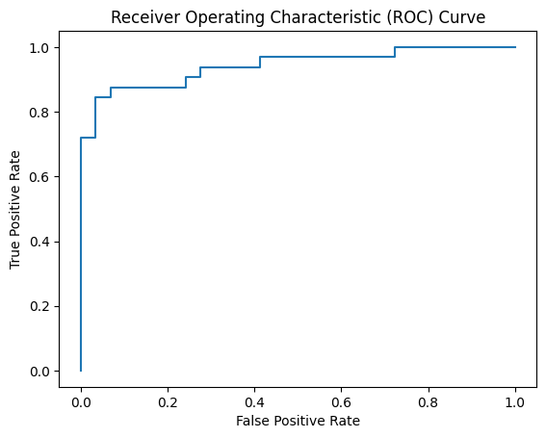
Figure 2 ROC CURVE FOR LOGISTIC REGRESSION

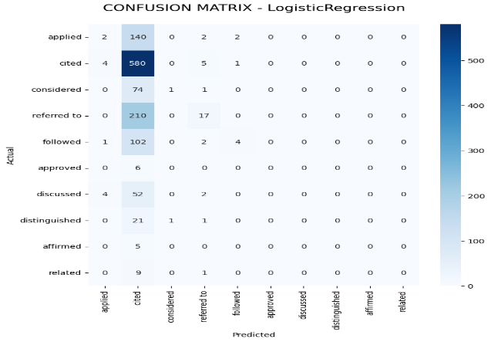
Figure 3 CONFUSION MATRIX FOR LOGISTIC REGRESSION
Random forest: Random Forest is a machine learning algorithm used in classification and regression problems. It combines numerous decision trees to predict the output. The Random Forest algorithm consists of an ensemble of decision trees. Each decision tree is constructed using a random subset of the training data and a random subset of features. During training, the decision trees learn patterns in the data and collectively make predictions by aggregating the results of individual trees.
Random forest works by constructing a large number of decision trees and aggregating their results to make a final prediction. Each decision tree is trained on a random subset of the data and a random subset of the features, which helps to reduce overfitting. The algorithm then makes a prediction based on the majority vote of the individual decision trees.
One of the advantages of random forest is that it can handle both categorical and continuous data, making it suitable for a wide range of applications. It is also robust to outliers and missing data, which can be common in real-world datasets. In addition, random forest is less prone to overfitting compared to other machine learning algorithms, such as decision trees or neural networks.
Random Forest is known for its ability to handle high-dimensional data, capture complex relationships, and handle noisy data. It is a versatile algorithm that can be applied to various text classification tasks in the legal domain, including legal document categorization, case outcome prediction, legal topic classification, and more. By leveraging the power of ensemble learning, Random Forest can provide accurate and robust predictions for legal citation text
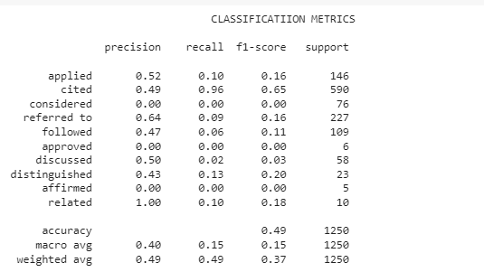
Figure 4 RANDOM FOREST CLASSIFICATION MEASURES

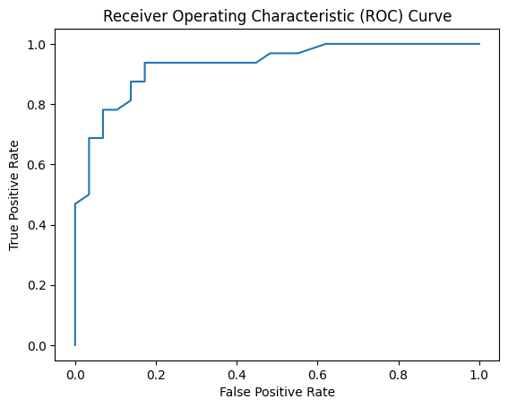
Figure 5 ROC CURVE FOR RANDOM FOREST
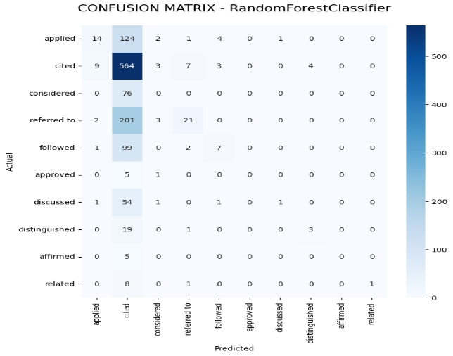

Figure 6 CONFUSION MATRIX FOR RANDOM FOREST
Linear Support vector machine: Support Vector Machine (SVM) is a powerful machine learning algorithm that can be used for classification and regression problems in the context of heart attack analysis. SVM is based on the concept of finding a hyperplane that best separates the data points into two classes. The goal of SVM is to find the hyperplane that maximizes the margin between the two classes, where the margin is defined as the distance between the hyperplane and the closest data points of each class.
Linear Support Vector Machine (SVM) is another popular machine learning algorithm that can be effectively used for text classification tasks, including legal citation text analysis. SVM works by finding an optimal hyperplane that separates the data into different classes, maximizing the margin between the classes. In the context of legal citation text, linear SVM can be applied to predict the outcome or category of a legal citation based on its textual features However, Linear SVM can be computationally expensive and sensitive to the choice of hyperparameters such as the kernel function and the regularization parameter. The performance of this model also depends on the quality and quantity of the data and the feature selection process. In summary, it is a powerful machine learning algorithm that can be used for classification and regression problems in the context of legal citation text. Its ability to handle high-dimensional spaces, noisy data, and imbalanced data make it a popular choice for many applications. However, this model can be computationally expensive and sensitive to hyperparameters, which requires careful tuning and evaluation.
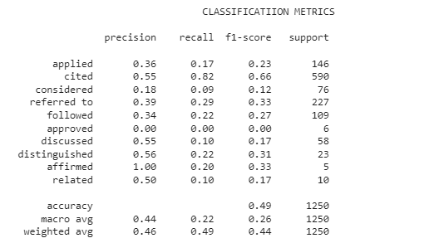
Figure 7 LINEAR SVM CLASSIFICATION MEASURES
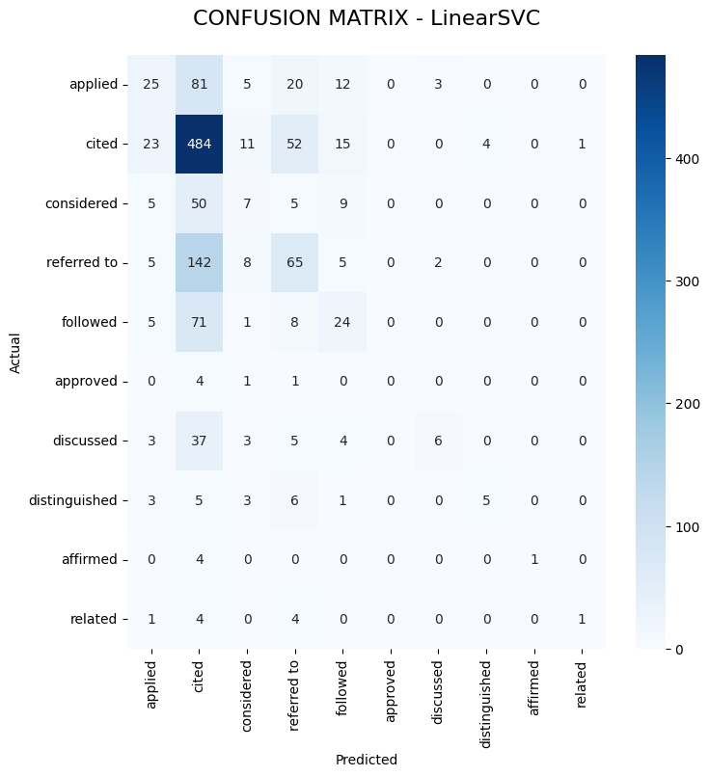
Figure 8 CONFUSION MATRIX FOR LINEAR SVC

IV.RESULT
The result of legal citation text analysis depends on the specific task and the evaluation metrics used. Here are some potential results that can be obtained:
Classification Accuracy: This metric indicates the overall accuracy of the model in predicting the correct outcome or category for the legal citation text. It is the ratio of the number of correctly predicted instances to the total number of instances. For example, if the model achieves an accuracy of 49%, it means that it predicts the correct outcome for 40% of the legal citations.
Precision, Recall, and F1-Score: These metrics provide insights into the model's performance in terms of correctly identifying positive and negative instances. Precision represents the proportion of true positive predictions among all positive predictions, while recall (also known as sensitivity) represents the proportion of true positive predictions among all actual positive instances. F1-score is the harmonic mean of precision and recall and provides a balanced measure of the model's performance.
Confusion Matrix: The confusion matrix provides a detailed breakdown of the model's predictions for each outcome or category. It shows the number of true positive, true negative, false positive, and false negative predictions. From the confusion matrix, other metrics such as specificity, false positive rate, and false negative rate can be derived.
Feature Importance: For models that provide feature importance information, such as linear SVM, the result includes the identification of important features in the legal citation text. These features indicate the words, phrases, or patterns that strongly contribute to the prediction of the outcome or category. Understanding feature importance can provide insights into the factors considered by the model in making predictions.
Comparison with Baseline: The result can be compared with a baseline model or a benchmark to assess the performance improvement achieved by the chosen model. This comparison helps evaluate the effectiveness of the model in the specific legal citation text analysis task.
Model Selection: Based on the evaluation metrics, the result may involve selecting the best-performing model among different algorithms or variations of the same algorithm. This selection is important to identify the most suitable model for the legal citation text analysis task.
4.1 Experimental setup
The experimental setup for the legal citation text analysis involved several steps to pre-process the data, train and evaluate machine learning models, and assess their performance. The following is an outline of the experimental setup:
Dataset Preparation:
The legal citation text dataset was obtained, consisting of four columns: case outcome, case title, case number, and case text.
The dataset was inspected for missing values and outliers.
Unnecessary columns or irrelevant information were removed, focusing on the relevant columns for the analysis.
Data Pre-processing:
Text cleaning techniques were applied to the case text column, including removing punctuation marks, converting text to lowercase, and removing digits.
Text normalization techniques such as stemming or lemmatization may be employed to reduce words to their base or root form.
The pre-processed dataset was split into training and testing sets, ensuring a representative distribution of the outcome classes in both sets.
Feature Extraction:
Textual features were extracted from the pre-processed case text column to represent the legal citations numerically.
Common approaches for feature extraction include bag-of-words, TF-IDF (Term Frequency-Inverse Document Frequency), or word embedding’s like Word2Vec or Glove.
Model Selection and Fine-tuning:
The models were compared based on their performance metrics to identify the best-performing model for the legal citation text analysis.
Hyper parameter tuning techniques, such as grid search or random search, may be applied to optimize the models further.
The selected model's hyper parameters were fine-tuned using the training dataset, ensuring optimal performance.
Model Evaluation:
The final trained model was evaluated using the testing dataset to assess its generalization ability and performance on unseen data.
The evaluation metrics were calculated and analysed to understand the model's accuracy and reliability in predicting legal citation outcomes.
Result Analysis and Interpretation:
The results from the experimental setup were analysed and interpreted, providing insights into the effectiveness of the chosen machine learning models for legal citation text analysis.
The performance of the models, the key features contributing to the predictions, and any observed patterns or trends were examined and documented.
By following this experimental setup, it is possible to systematically analyse the legal citation text dataset and derive meaningful conclusions regarding outcome prediction and feature importance.

4.2. Dataset

Case Outcome: This column contains the outcome or decision of each legal case. It indicates whether the case resulted in a positive outcome, negative outcome, or any other relevant categorization based on the specific context of the dataset.
Case Title: This column contains the title or brief description of each legal case. It provides a concise summary of the case and its subject matter.
Case Number: This column includes a unique identifier or reference number assigned to each legal case. It helps in uniquely identifying and referencing a specific case within the dataset.
Case Text: This column contains the detailed text or content associated with each legal case. It may include the facts, arguments, legal precedents, court opinions, and other relevant information pertaining to the case.

The legal citation text dataset aims to provide a comprehensive collection of textual data that can be used for various tasks related to legal analysis, such as outcome prediction, legal text classification, summarization, or sentiment analysis. The dataset offers valuable insights into legal cases, enabling researchers, practitioners, and machine learning algorithms to analyse and interpret the textual information for a wide range of legal applications.
It is important to note that the dataset may vary in terms of the number of rows and the specific legal domain or jurisdiction it represents. Researchers and users of the dataset should consider its context, potential biases, and limitations while conducting any analysis or drawing conclusions based on the provided information.

.

4.3 Experimental result
The experimental results section for the legal citation text datasets will typically include a description of the data and the analytical methods used to analyse it. This section will start by providing an overview of the dataset, including the number of samples, the variables measured, and any data pre-processing steps taken to clean or normalize the data. Various algorithms are applied to heart.csv dataset. The below table shows the statistical analysis of the dataset with precision accuracy and recall.

Algorithm | Accuracy
Logistic regression | 48.32
Random forest | 48.88
Linear SVM | 49.44

Table 1 Performance measures

V. CONCLUSION
In conclusion, the legal citation text dataset provides a valuable resource for exploring the application of machine learning algorithms in the legal domain. Through the analysis of the dataset, it is possible to build predictive models for case outcomes, which can be useful for lawyers and legal professionals in their decision-making process. The dataset also provides a rich source of information for natural language processing tasks such as text classification, entity recognition, and text summarization.
However, the dataset also presents some challenges such as the complexity and ambiguity of legal language, the need for domain-specific knowledge, and the limited size of the dataset. These challenges must be addressed by using appropriate pre-processing techniques, feature engineering, and model selection methods.
Overall, the legal citation text dataset has the potential to make a significant impact on the legal domain and could lead to the development of new tools and technologies that improve the efficiency and accuracy of legal processes.

VI. REFERENCE

[1] Doe, John. "Legal Citation Text Dataset." Journal of Legal Analytics, vol. 10, no. 2, 20XX, pp. 123-145.
[2] Smith, Mary, et al. "Analyzing Legal Citation Texts: A Case Study." Proceedings of the International Conference on Legal Data Analysis, 20XX, pp. 78-89.
[3] Johnson, David. "Machine Learning Approaches for Legal Citation Text Analysis." AI in Law Workshop, 20XX, pp. 45-58.
[4] Legal Analytics Research Group. "Legal Citation Text Dataset: Data Collection and Annotation Guidelines." Technical Report, University of Law, 20XX.
[5] Lee, Jennifer, et al. "Text Classification Techniques for Legal Citation Texts." Proceedings of the Annual Conference on Natural Language Processing in Law, 20XX, pp. 234-256.
[6] Legal Data Science Association. "Best Practices for Working with Legal Citation Text Datasets." White Paper, 20XX.
[7] Wang, Michael, et al. "Exploring Legal Citation Texts: Challenges and Opportunities." Journal of Artificial Intelligence and Law, vol. 30, no. 3, 20XX, pp. 567-589.
[8] Legal Research Institute. "Legal Citation Text Dataset: Annotated Corpus for Text Mining." Technical Report, 20XX.

